**MSEG 302 – Midterm 2 – 27 April 2017**

Student Name ____________________________________

Student Number __________________________________

Questions are each worth three (3) points except the last (1 point) for a total of 100 points.

**1.** Why does this concentration profile represent steady state diffusion?



a. All diffusion is steady state

b. Its vacancy diffusion

c. The second derivative of concentration with distance is zero

d. Because of the error function

**2.** What is C(x,t) when time goes to infinity (i.e. for long times) 1 cm below the surface?



a. Cs b. C0

c. Zero d. Infinity

**3.** What is Qd in the below equation?

D = D0 exp(-Qd/RT)

a. Pre-exponential factor

b. Activation energy

c. Gas constant

d. Diffusion coefficient

**4.** What is the error function of 1.05?

a. 0.8615 b. 0.8707

c. 0.8521 d. 0.8427

**5.** A metal slab initially contains no nitrogen. Nitrogen with a surface concentration of   
0.2 wt% is diffused into it at 675°C, where the diffusion coefficient of nitrogen in the metal is 2.8×10-11 m2/s. The concentration is measured to be 0.075 wt% at a distance of   
2 mm from the surface, how long has the slab been in contact with the gas?

a. 1 h b. 25 h

c. 100 h d. 2.5×107 h

**6.** Using the graph at the end of this exam state which form of iron, α-Fe or -Fe, has a larger diffusion coefficient for carbon at 900°C

a. They are both equal

b. α-Fe c. -Fe

**7.** Referring to Question 6, α-Fe has an BCC crystal structure while -Fe has an FCC, explain why one has a greater diffusion coefficient than the other, or why they are equal.

a. They are equal because it is Carbon diffusing in Iron in both cases

b. The atomic packing factor is lesser in the one where diffusion is faster

c. The atomic packing factor is lesser in the one where diffusion is slower

d. In the faster diffusing case it is interstitial diffusion while in the other it is substitutional diffusion

**8.** Explain why diffusion of Iron in Iron is always slower than Carbon in Iron.

a. Iron in Iron is substitutional diffusion

b. Carbon in Iron is interstitial diffusion

c. Carbon is a smaller atom than Iron

d. All the above

**9.** The reason why Carbon increases the tensile strength of iron is:

a. it occupies a vacancy

b. it occupies a dislocation

c. it is an interstitial

d. it raises the melting temperature

**10.** If you want to estimate the shear modulus and you only know the modulus of elasticity, what other material property do you need to know?

a. The tensile strength b. The yield strength

c. Its yield strain d. Poisson’s ratio

**11.** A cylindrical nickel wire 2.0 mm in diameter and 3×104 mm long has a 300 N load put on it, determine its length change assuming the deformation is totally elastic.

a. 1.38×10-5 mm b. 13.8mm

c. 1.38×104 mm d. 1.38×1010 mm

**12.** A steel alloy must have a modulus of resilience of at least 2.07 MPa, what must be its minimum yield strength?

a.8.57 MPa b. 2.93 MPa

c. 29.3 MPa d. 926 MPa

**13.** Assuming a safety factor of 2, determine the working stress of steel.

a. 90 MPa b. 180 MPa

c. 190 MPa d. 380 MPa

**14.** A metal has a dislocation density of   
108 mm-2, assume the dislocations in a 1 cm3 cube can be laid end-to-end and determine their length.

a. 105 m b. 106 m

c. 107 m d. 108 m

**15.** Consider a metal single crystal oriented such that the normal to the slip plane and the slip direction are at angles of 60° and 35°, respectively, with the tensile axis. If the critical resolved shear stress is 6.2 MPa will an applied stress of 16 MPa cause the single crystal to yield?

a. yes b. no

**16.** A glass plate is subjected to a tensile stress of 40 MPa. If the specific surface energy and elastic modulus are 0.3 J/m2 and 69 GPa, respectively, determine the critical crack length for an internal crack.

a. 4.1 µm b. 8.2 µm

c. 16.4 µm d. 24.6 µm

**17.** The ductile-to-brittle fracture transition refers to:

a. A critical concentration of Carbon in steel

b. Temperature causing this effect

c. Necking in a tensile test

d. Inability of crystals to orient

**18.** A large plate is fabricated from a steel alloy that has a plane strain fracture toughness of 82.4 MPa-m1/2. If the plate is exposed to a tensile stress of 345 MPa, determine the minimum length of a surface crack that will lead to fracture.

a. 9.1 mm b. 18.2 mm

c. 36.4 mm d. 57.2 mm

**19.** An S-590 iron component must have a creep rupture lifetime of at least 20 days at 650°C. Compute the maximum allowable stress level.

a. 750 MPa b. 700 MPa

c. 350 MPa d. 250 MPa

**20.** Once a system is at a state of equilibrium, a shift from equilibrium may result by alteration of which of the following?

a. Pressure b. Composition

c. Temperature d. All the above

Below is the Copper-Nickel phase diagram the following four questions refer to it for a   
40 wt% Nickel concentration.

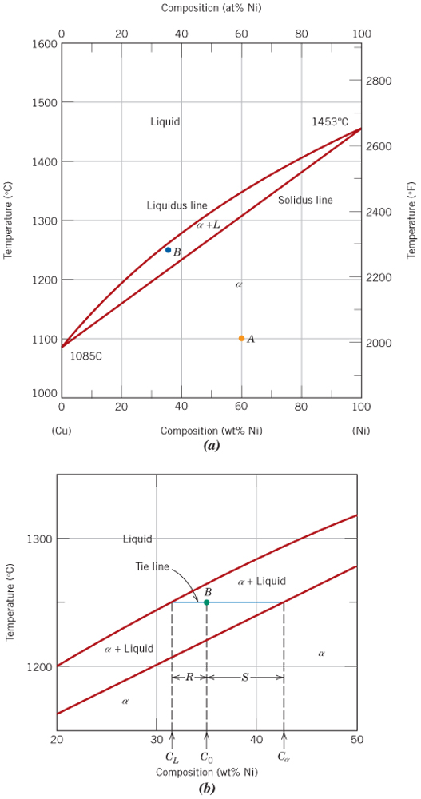

**21.** At what temperature does the first solid phase form?

a. 1085°C b. 1280°C

c. 1453°C d. Never

**22.** What is the composition of this solid phase?

a. 0 wt% Ni b. 40 wt% Ni

c. 53 wt% Ni d. It never forms

**23.** At what temperature does the last of the liquid solidify?

a. 1085°C b. 1230°C

c. 1453°C d. Never

**24.** What is the composition of this last remaining liquid phase?

a. 0 wt% Ni b. 30 wt% Ni

c. 40 wt% Ni d. It never forms

The next three questions refer to this phase diagram for Lead and Tin.

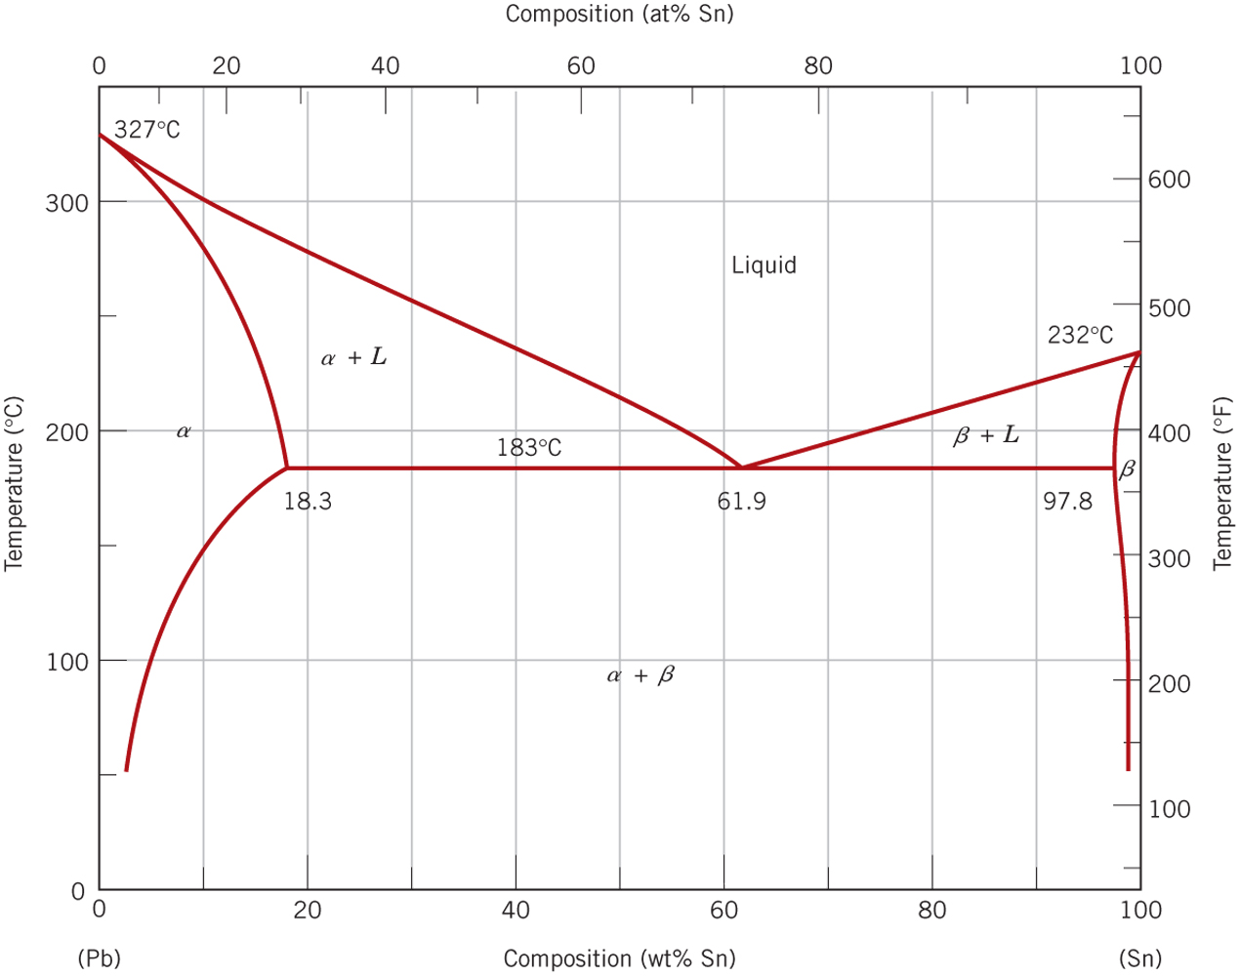

**25.** Find the temperature where it is only possible to have the liquid phase.

a. 327°C b. 232°C

c. 183°C d. 0°C

**26.** Consider a mixture having 20 wt% Tin at 250°C, what is the Tin composition of the α phase?

a. 13 wt% b. 18.3 wt%

c. 32 wt% d. 61.9 wt%

**27.** What weight fraction of the mixture will be the α phase for Question 26?

a. 0.37 b. 0.45

c. 0.63 d. 1.0

**28.** What is the advantage of using a eutectic solder like Lead-Tin?

a. It gradually solidifies a temperature is decreased

b. It is not harmful to the environment

c. It rapidly solidifies as temperature is decreased

d. It is stronger than other solders

**29.** Salt is used to “melt” water with its phase diagram given below. If you have a 10 wt% salt solution that you cool to -10°C what is the salt concentration in the solid phase?

a. 0.0 wt% b. 13.5 wt%

c. 24.0 wt% d. 76.0 wt%

**30.** What is the driving force for diffusion, a difference in?

a. Temperature b. Pressure

c. Concentration d. Time

**31.** What is true about the relation between engineering and true stresses?

a. they are equal

b. true stress is larger

c. engineering stress is larger

d. neither are useful

**32.** Determine the percentage change in the tensile strength of a brass rod if its diameter is reduced by 40% by cold work.

a. 10% b. 50%

b. 100% d. 130%

**33.** A brittle fracture forms a cup-and-cone type of fracture surface.

a. true b. false

**34.** Materials science is:

a. cool b. fascinating

c. amazing d. all the above

Avogadro’s number = 6.02×1023 #/mol, Gas constant = 8.32 J/mol-K

Boltzmann’s constant = 1.38×10-23 J/atom-K = 8.62×10-5 eV/atom-K

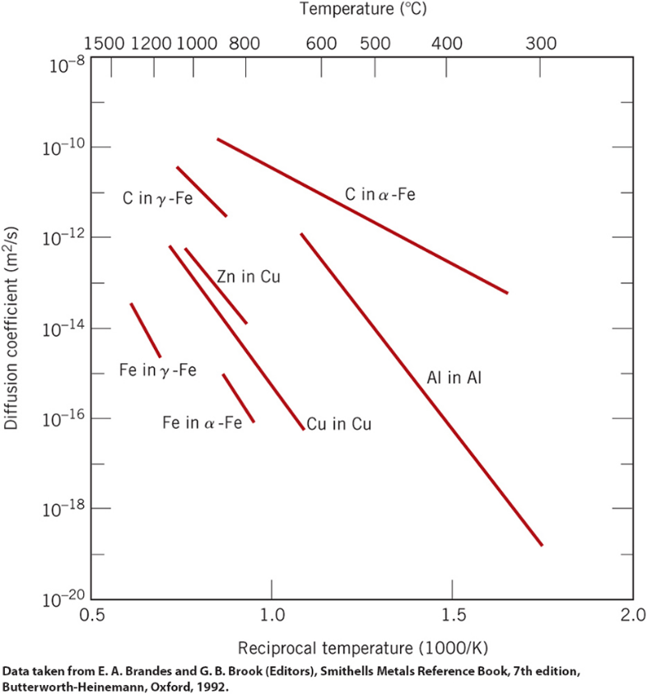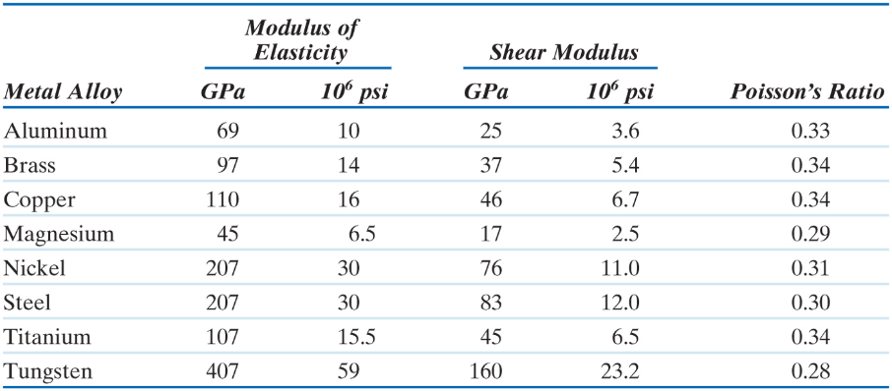CuK radiation wavelength is 0.154 nm

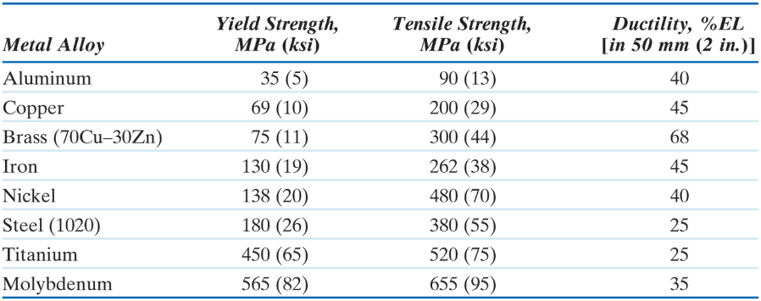

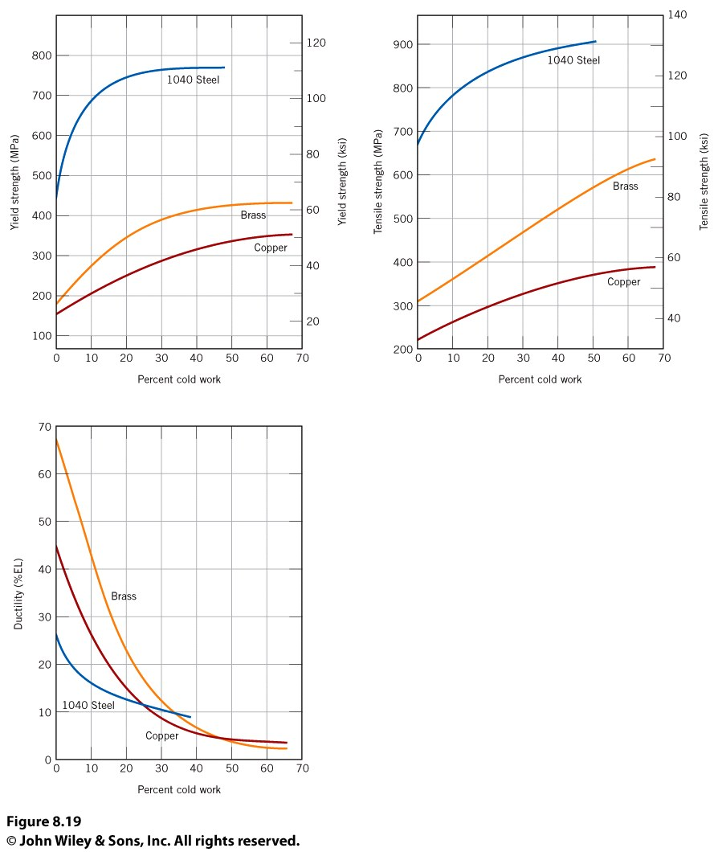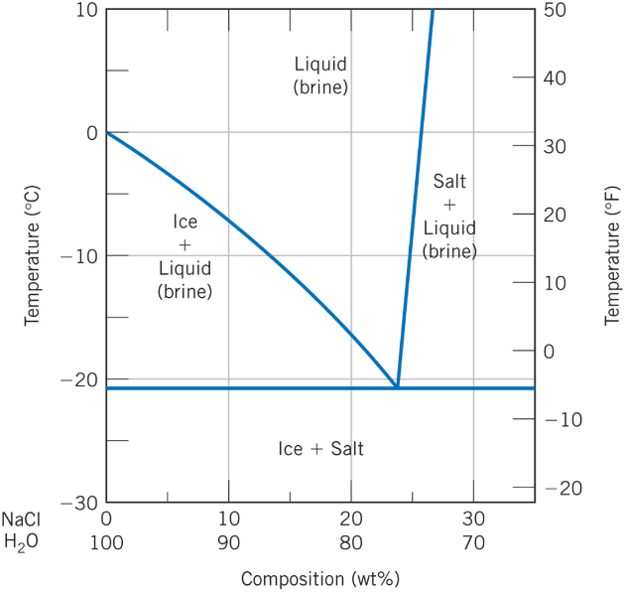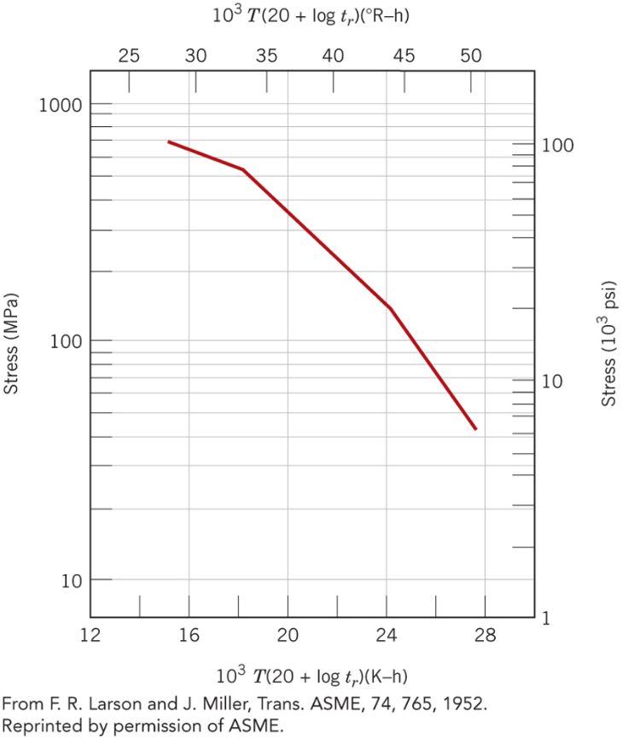

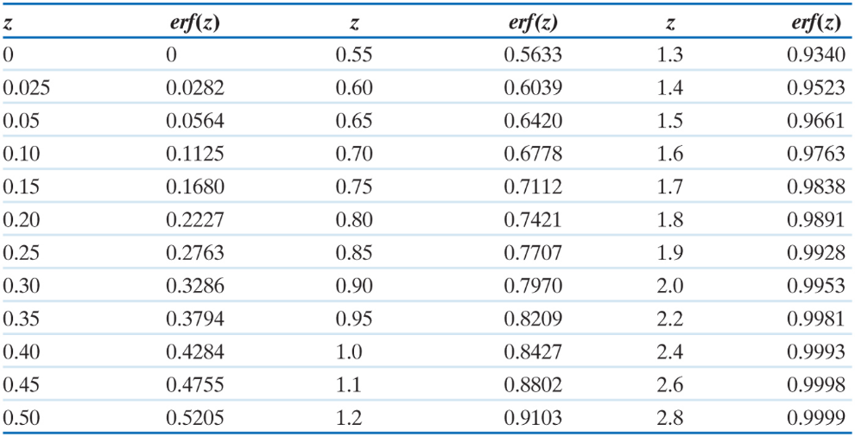 CuK radiation wavelength is 0.154 nm

S-590 Alloy

S590 Iron